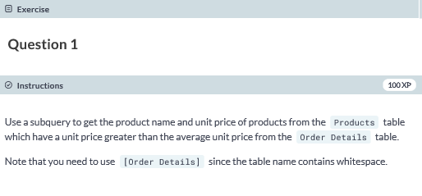

**SELECT ProductName, UnitPrice FROM dbo.Products**

**WHERE UnitPrice >**

**(SELECT AVG(UnitPrice) FROM dbo.[Order Details]);**

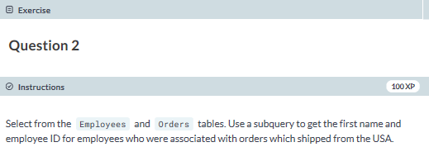

**SELECT DISTINCT e.FirstName, e.EmployeeID**

**FROM dbo.Employees AS e**

**JOIN dbo.Orders AS o**

**ON e.EmployeeID = o.EmployeeID**

**WHERE o.ShipCountry = 'USA';**

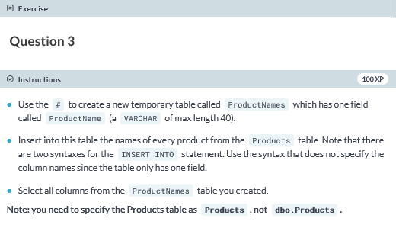

**CREATE TABLE #ProductNames**

**(ProductName VARCHAR(40));**

**INSERT INTO #ProductNames SELECT ProductName FROM Products;**

**SELECT * FROM #ProductNames;**